AOIR Research Projects
Head of Project: Shivam Vahia (Managing Director)
Acknowledgements: Wikipedia
Military Channel
Call of Duty 2 (Activision)
World war.net
And others……..
Sub-Topics in this report:
- WWII Timeline
- Nazis
- Axis Force
- Allied Force
- Armament
- War Heroes
- Synopsis
- Aftermath
- Picture Gallery

© AOIR India 2012 WWW.AOIR.CO.IN Original Copy

About AOIR:
AOIR (All over Indian range) was formed on 2nd May 2004 in Mumbai. It worked only for India, is working for India and will be working for India.
It was founded by Shivam Vahia, and its mission is ‘DEVELOPMENT OF INDIA IN THE FIELD OF TECNOLOGY, DEFENSE, INNOVATION, POVERTY, EDUCATION AND OTHER SECTORS…’

AOIR Projects is a division of AOIR India, working in the field of anonymous topics.

The World War 2
World War II, or the Second World War (often abbreviated as WWII or WW2), was a global war that was under way by 1939 and ended in 1945. It involved a vast majority of the world's nations—including all of the great powers—eventually forming two opposing military alliances: the Allies and the Axis. It was the most widespread war in history, with more than 100 million people serving in military units. In a state of "total war", the major participants placed their entire economic, industrial, and scientific capabilities at the service of the war effort, erasing the distinction between civilian and military resources. Marked by significant events involving the mass death of civilians, including the Holocaust and the only use of nuclear weapons in warfare, it resulted in 50 million to over 70 million fatalities. These deaths make the war the deadliest conflict in human history.
Although Japan was already at war with China in 1937, the world war is generally said to have begun on 1 September 1939, with the invasion of Poland by Germany, and subsequent declarations of war on Germany and Italy by France and most of the countries of the British Empire and Commonwealth. Germany set out to establish a large empire in Europe. From late 1939 to early 1941, in a series of campaigns and treaties, Germany conquered or subdued much of continental Europe; amid Nazi-Soviet agreements, the nominally neutral Soviet Union fully or partially invaded, occupied, or annexed territories of its six European neighbors, including Poland. Britain and the Commonwealth remained the only major force continuing the fight against the Axis, with battles taking place in North Africa as well as the long-running Battle of the Atlantic. In June 1941, the European Axis launched an invasion of the Soviet Union, giving a start to the largest land theatre of war in history, which tied down the major part of the Axis' military forces.

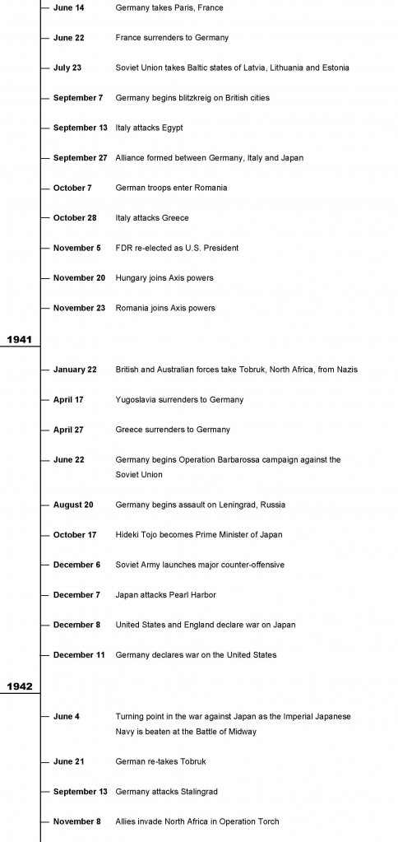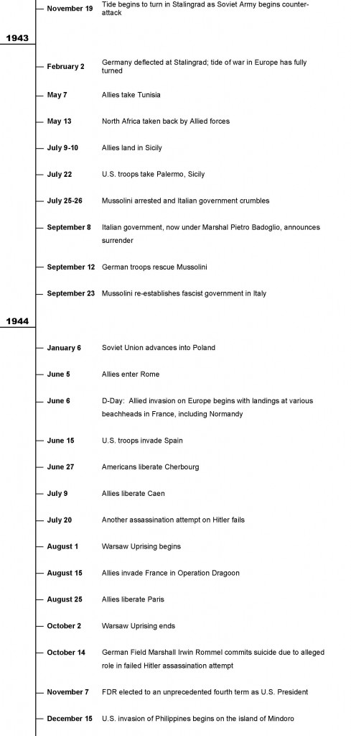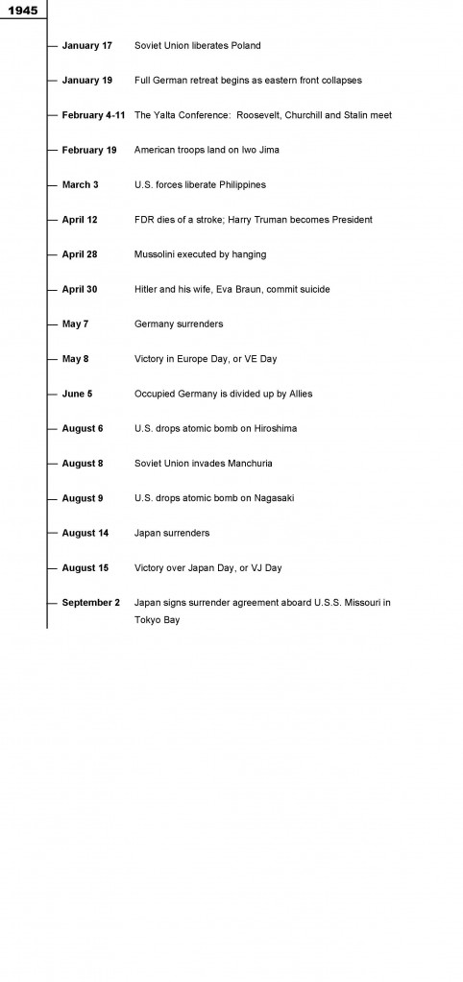
WWII Timeline

